1. Examples from the browser are displaying the image related to the currently predicted emotion displayed alongside the motivational quote generated.

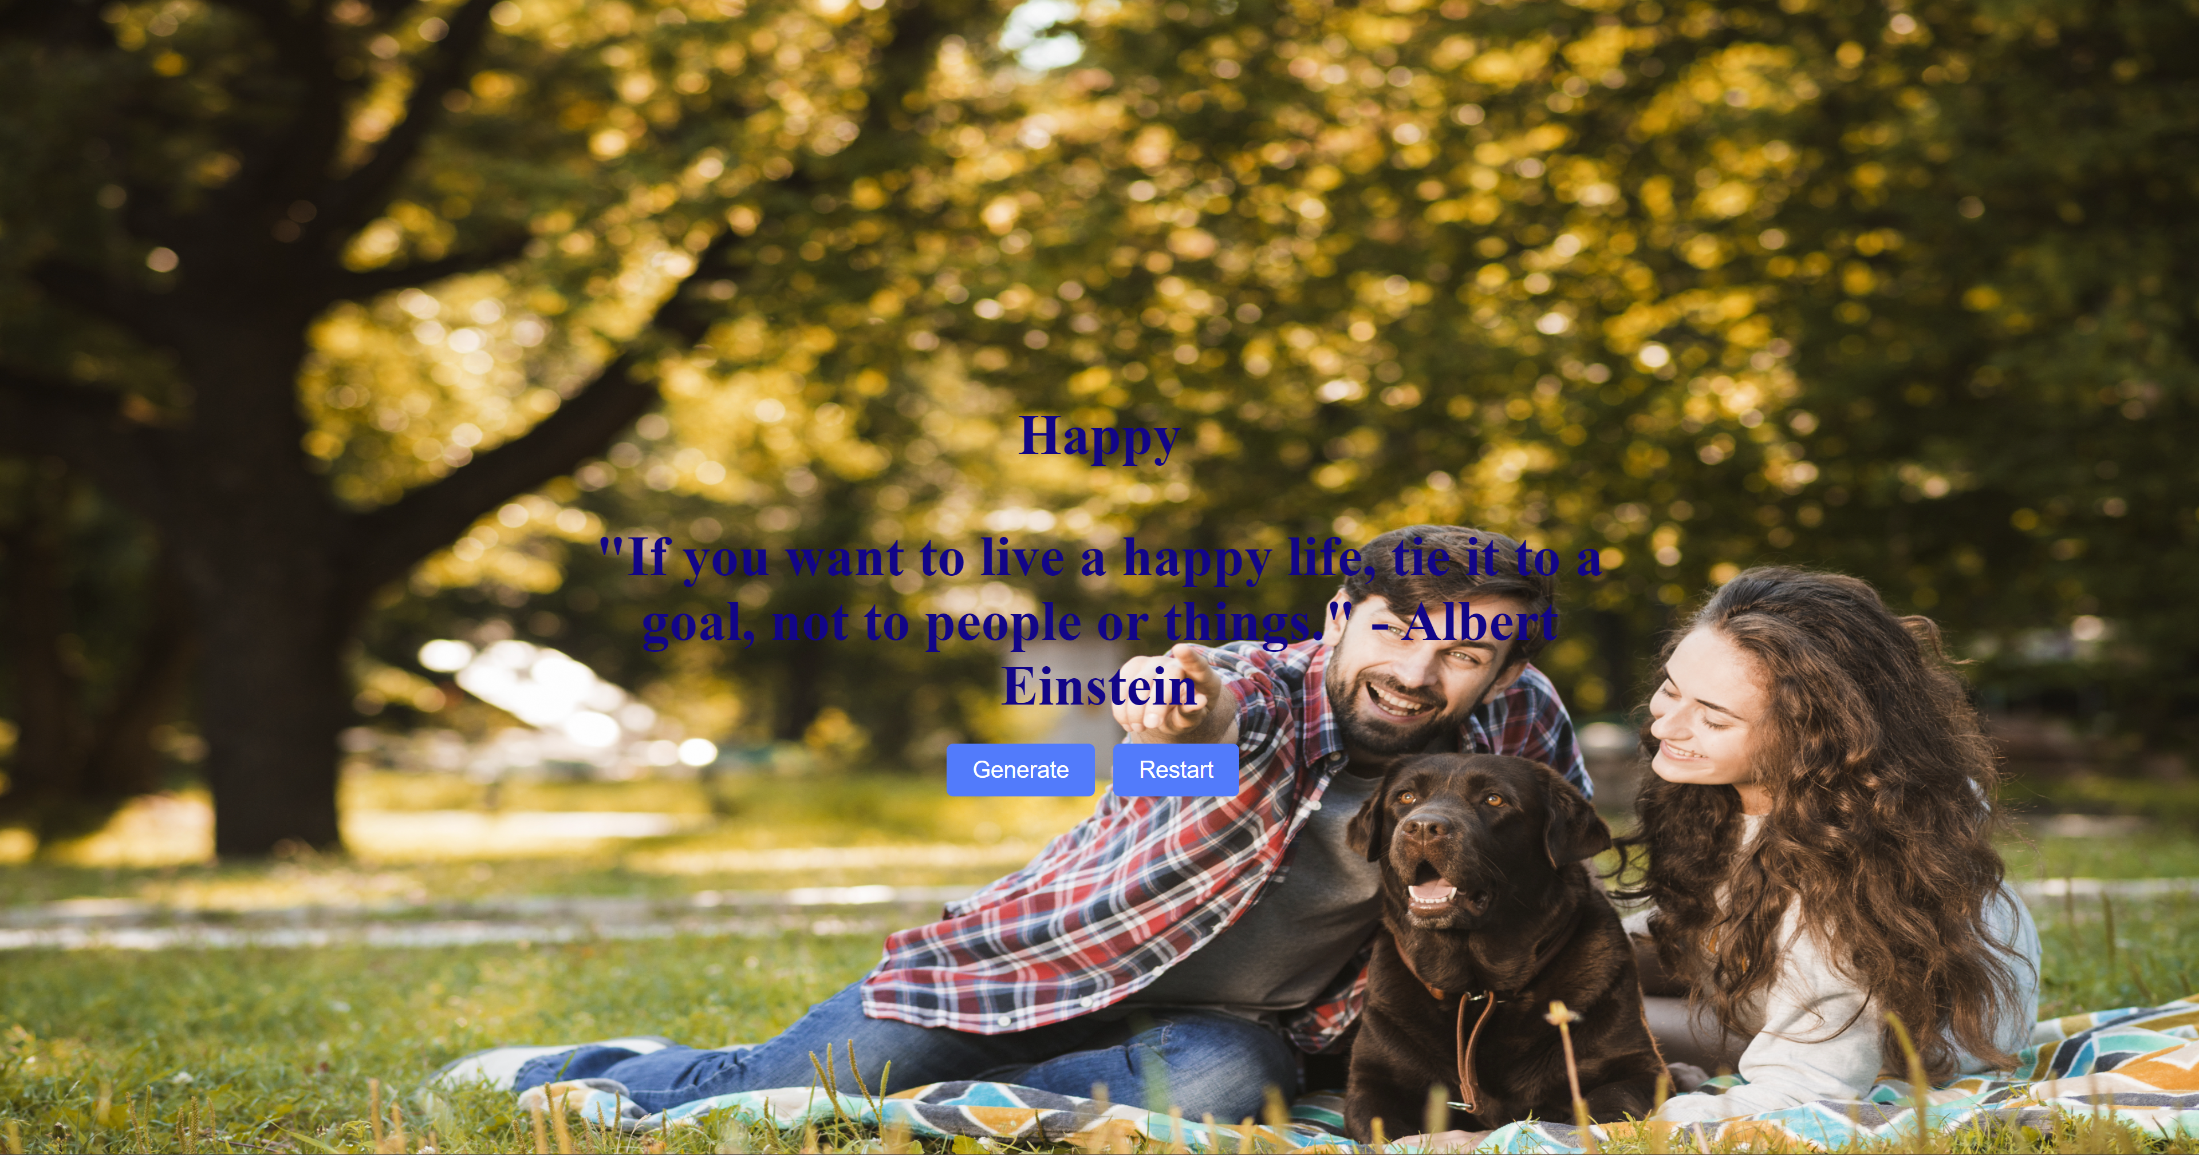

Figure 1



Figure 2

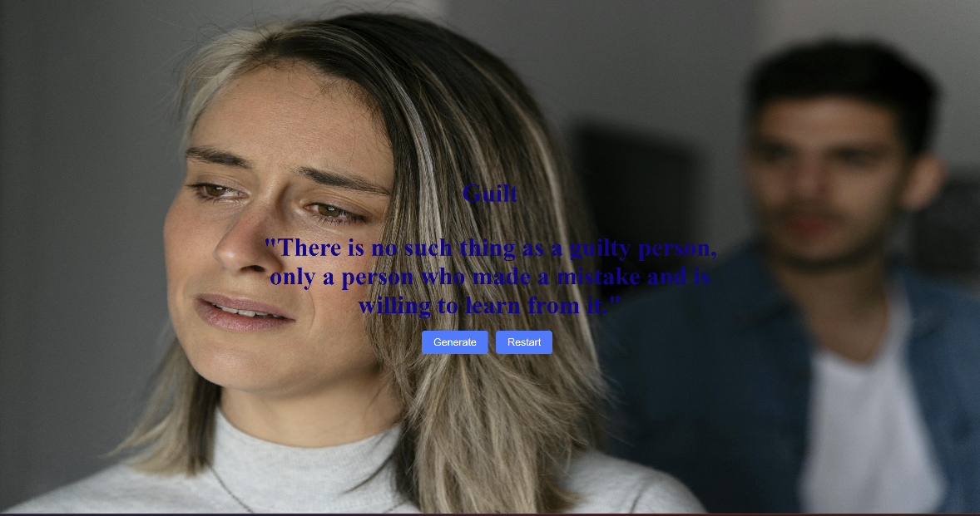Figure 3



Figure 4

1. Examples from the main class running on the terminal.

* Accuracy: 0.2727272727272727
* Predicted emotion: Anxiety

Motivational quote: "Anxiety is like a rock in your shoe. It's annoying and makes it hard to walk, but you can still shake it out and continue on your journey."

* Predicted emotion: Panicked

Motivational quote: "You are not alone. We are in this together and we will get through this together."

* Predicted emotion: Guilt

Motivational quote: "Your guilt is a symptom of your humanity. Don't let it become your identity." -Brené Brown

* Predicted emotion: Anxiety

Motivational quote: "The only way to do great work is to love what you do." -Steve Jobs

* Predicted emotion: Panicked

Motivational quote: You are not alone. Millions of people around the world feel exactly like you do in this moment. But they don't let their panic define them. They use it as fuel to push themselves harder and become better versions of themselves. You can

* Predicted emotion: Anxiety

Motivational quote: "Everything will be alright in the end. If it's not alright, it's not the end."

* Predicted emotion: Loneliness

Motivational quote: "No one is ever truly alone. Those who live no more, who have left us, still live in our hearts, our memories, and our love."

* Predicted emotion: Guilt

Motivational quote: "What's done is done. You can't change the past, but you can learn from it and move on."

* Predicted emotion: Panicked

Motivational quote: "Don't panic. Take a deep breath and think about what you need to do."

* Predicted emotion: Anxiety

Motivational quote: "Anxiety is like a storm, it comes and it goes. Ride it out and be patient, it will eventually pass."

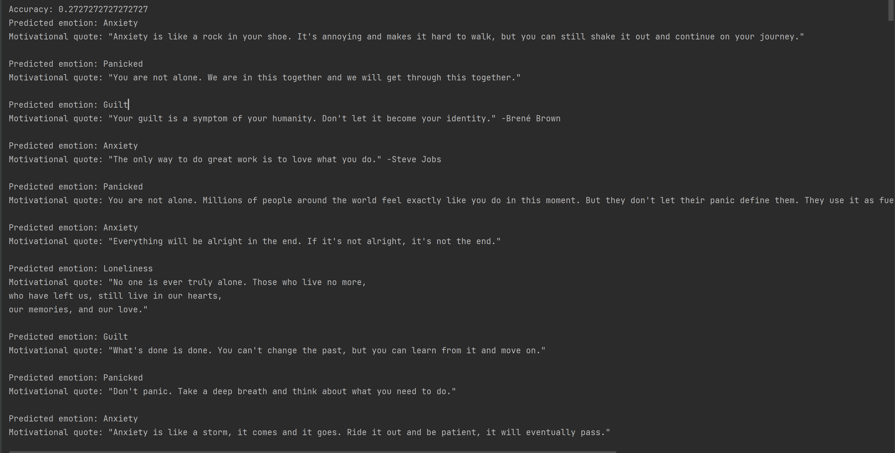

Figure 5